Biological Identification

Introduction to recognizing attributes, comparative anatomy, using dichotomous keys, and other skills to aid in identifying organisms

Julie M. Schlichte, Mingna (Vicky) Zhaung

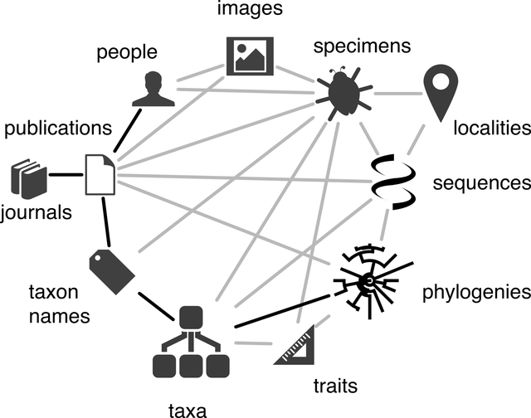
Adapted from WikiMedia Commons

Description

This module is for a broad scope of classes/labs that require students to identify, classify, or recognize organisms. It is meant to be an introduction which can be easily modified/added to for any class (by inserting your taxa of interest). It is appropriate for undergraduate and graduate classes in which identification of biological organisms is a learning objective. Examples are provided using vertebrates, invertebrates, and plants. Students will learn why identification is important, learn how museum specimens can be used in comparative anatomy, get familiar with field guides and online resources, work through a dichotomous key, and (optionally) recognize key attributes in identification in their given taxa. This module is designed to be taught in-person (which helps students discuss answers and look at actual museum specimens) but is easily adapted to teach online. The full module is expected to take 3 hours; however, each activity is expected to take 45-60 minutes, and can be scaled up or down.

Introduction to Biological Identification (for students)

The ability to identify organisms is essential to our survival. As a child, you probably learned the difference between a tree, a bush, a bird, a fish, a turtle, and a snake. You were already using identification techniques. Historically, the ability to identify organisms that could be harmful was of great importance (don’t eat that berry, that snake is venomous, etc.). Currently, we still need the basic knowledge of how to identify an organism (even if it’s not a life-or-death scenario). If you were walking with a toddler who wanted to touch a cactus, how would you know this might be dangerous? If you were camping and foraged some mushrooms, how do you know they are safe to eat? Some identification of organisms is obvious (cacti have spines), and some are more elusive (spores from wild mushrooms).

The ability to identify organisms starts with learning what traits to look for. This will vary by taxa (shell structure in mollusks, feather colors in birds, skull structure in vertebrates, etc.), but a basic understanding of how to look for distinguishing features is useful for all fields of biology, ecology, and environmental science. Furthermore, understanding how to use tools such as field guides, dichotomous keys, comparative anatomy from museum specimens, and online search tools is essential to your ability to identify organisms upon sight. Your professors are already excellent at identifying organisms, but they all started where you are now!

We currently have genetic and molecular techniques, such as PCR, to classify organisms, identify hybrids, and double-check suspected occurrences of speciation. This technology is an amazing leap forward in our understanding of the ever-branching tree of life, but it still requires the researcher to have an idea of which organisms they have (before running analysis, called “a priori”). If you were hired to see if construction of a new bridge would affect local organisms, you wouldn’t have the time or resources to get DNA from every organism in the vicinity. You’d rely on your own knowledge of identification, plus other resources to help you determine the range and vulnerability of each organism. One person can never have the knowledge to identify every organism in the world (or even in one city), but you will learn how to identify characteristics and learn how to use tools that will aid in your ability to identify any living organism.

Learning objectives
- Understand why identifying biological organisms is important
- Learn how to follow a dichotomous key
- Explore the applications of comparative anatomy when identifying an organism
- Learn how to efficiently use a field guide
- Generate range maps for species of interest
- Apply knowledge to identification of specific taxa

Required website links:
- ARCTOS: https://arctosdb.org/
- GBIF: https://www.gbif.org/
Glossary: vocabulary you need to know to complete this module
Binomial nomenclature:
Comparative anatomy:
Dichotomous key:
PCR:
Species:
Species range:
Taxa:

Biological Identification: Background

The classification of biological organisms was initially done by Aristotle (384-322 BCE) and included the divisions of plants, animals, and humans. Aristotle distinguished animal species between those “with blood” and those “without [red] blood.” Aristotle was the first to group organisms together into what he called “genera.” In modern terms, genera refer to the genus of a given organism, but we have Aristotle to thank for the initial recognition that organisms should be classified (https://ucmp.berkeley.edu/history/aristotle.html).

Two thousand years after Aristotle, Carl Linnaeus (1707-1778) revived the principle of biological classification. He is considered the founder of modern taxonomy, as he introduced the idea of a hierarchy of nesting groups within groups and giving a two-word Latin name to every species (binomial nomenclature). We have since built upon Linnaeus’ hierarchical structure. (http://www.brooklyn.cuny.edu/bc/ahp/CLAS/CLAS.Linn.html#:~:text=His%20major%20groupings%20in%20the,since%20the%20time%20of%20Linnaeus.)

The major taxonomic ranks are Kingdom, Phylum, Class, Order, Family, Genus, Species (although many other ranks such as “subclass,” “superfamily,” and “infraorder” are often used). (https://animaldiversity.org/animal_names/rank_inconsistency/#:~:text=In%20the%2018th%20century%20Carolus,genus%2C%20species%2C%20and%20variety.)
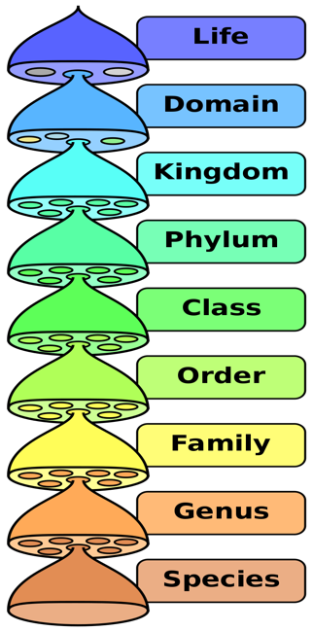
Today, we still use binomial nomenclature for every organism on Earth. For example, humans are Homo sapiens. The first word is the genus, and the second word is the specific epithet (or species name). When writing this Latin name of an organism, remember that the genus should always be capitalized, the specific epithet is lowercase, and the name should be italicized (when typing) or underlined (when writing by hand). An example using the grey wolf:
Genus: Canis
Specific epithet: lupus
Correct way to write the scientific name: Canis lupus
Some incorrect ways: canis Lupus, Canis Lupus, Canis lupus…

Current classification

Pre-lab activities for Biological Identification

Next class we will be focusing on Biological Identification. Instead of spending class time on background information, we want to devote as much time as possible to completing lab activities in class, so please access the following BEFORE class.

Read the following before class:
- Introduction to biological identification

Watch this video:
https://www.sciencelearn.org.nz/videos/2065-classifying-and-identifying (copyright Science Learning Hub – Pokapū Akoranga Pūtaiao, University of Waikato, www.sciencelearn.org.nz)

- Write a two-sentence summary of the video
- Come to class ready to discuss why biological identification is important

Biological Identification: Dichotomous Key Activity

Dichotomous keys are widely used by biologists to identify organisms. They are important scientific tools that help experts, as well as beginners, look at observable characteristics and come to a conclusion. They guide biologists through “yes-no” and “number of” questions to find an answer. Using a dichotomous key, you should be able to correctly identify an organism, even if you are not an expert (https://www.nps.gov/teachers/classrooms/dichotomous-key.htm)!
The following is a fictitious example of how to classify candy using a dichotomous key:
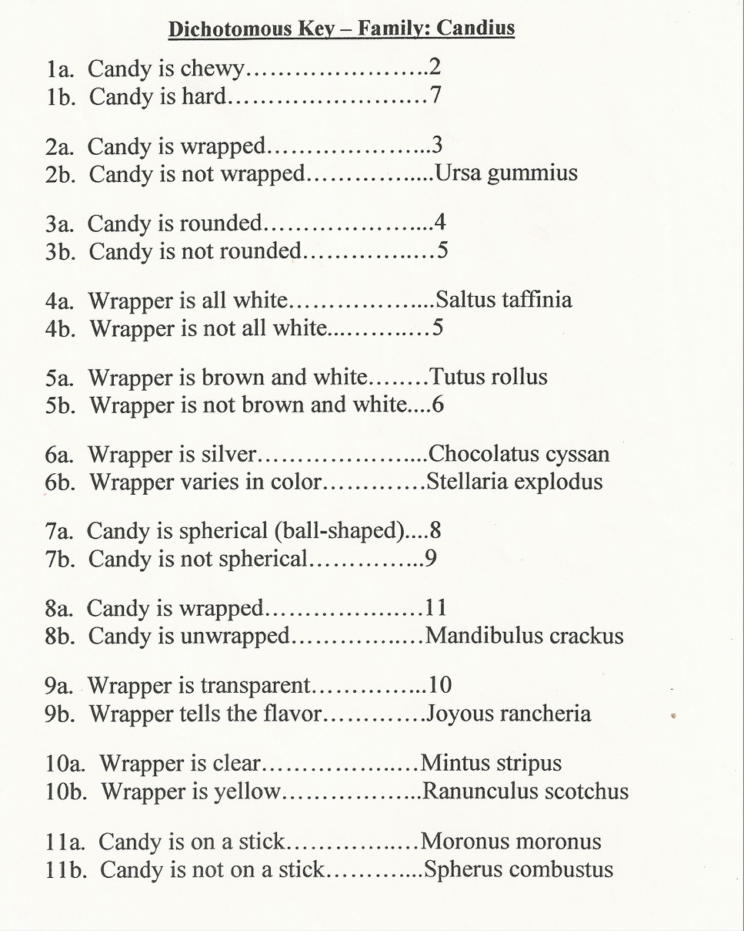
Image used with permission from: https://www.pinterest.com/pin/212161832420531263/

Working through a real dichotomous key can seem difficult, but knowing how to use them is incredibly useful in identifying organisms! In the following activities, you will make your own dichotomous keys, and work through an expertly published key to identify an unknown specimen!

Exercise 1:
Watch the following YouTube video: https://www.youtube.com/watch?v=peMiaDhw9sc
Write two sentences about how you may write your own dichotomous key.

Exercise 2:
In your lab group, make a dichotomous key for the following items (the names of items and an example of the first question are provided for you):
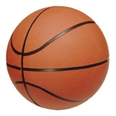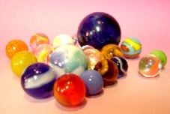
Soccer ball American football Crayons Basketball Teddy Bear Marbles

1a. The item is spherical…………………………5
1b. The item is not spherical…………………..2

Give your dichotomous key to another lab group. Circle the item they should identify. See if they can find the correct response using your key!

Exercise 3:
You will now make a dichotomous key for actual organisms (from the UTEP Biodiversity Collections). Your lab group can pick from the following series of images. You should include any taxa-specific terms in your key.

Image series 1: plant specimens (herbarium sheets)

Image series 2: birds (taxidermy)

Image series 3: mammals (skins)

Image series 4: reptiles (wet specimens)

Exercise 4:
Identify an unknown organism! Using what you’ve learned, your lab group will work through a published dichotomous key. Your TA/instructor will provide you with an actual museum specimen (and/or photographs of the specimen). You are encouraged to look up any terms you’re unfamiliar with. Provide example; instructors should be encouraged to find their own specimens and dichotomous keys relevant to the class

Biological Identification: Comparative Anatomy Activity

You found a bird in the field, and don’t know what species it is! This is where comparative anatomy, using museum specimens, can be very useful.

Online image searches are subject to individuals’ “ID” of species; they’re a good place to start, but not a great place to make a definitive identification.

Exercise 1:
Search Google images for your favorite bird or lizard. Answer the following:
- Does every image of the bird of your chosen species look the same? Why or why not?
- Do you think every observer posting these photos was able to correctly identify this bird?
- Do a new search with the scientific (Latin) name of your bird. What are the differences in your search results?
- Are you able to find female, male, and juvenile colorations? Seasonal variation? Geographical variation?

Exercise 2:
Search ARCTOS https://arctos.database.museum/SpecimenSearch.cfm for the same species you searched for in Exercise 1. You can type the common name or scientific name in the “Identification and Taxonomy” field.
- How many museum specimens did your results return?
- Complete your search again and select “image” under media type. Did you find any images of your species on ARCTOS? If so, how many?

You probably noticed that many more images are available using Google Images than ARCTOS, but when making a definitive identification, you can use the actual museum specimens listed in ARCTOS to compare to what you found in the field! It is possible to request images from a museum, or request the actual specimen. For the next activity, you will be provided with images from the UTEP Biodiversity Collections to practice comparative anatomy. You can also request the physical specimens from mzhuang@utep.edu

Exercise 3:
Taxa-specific activity: provide 5-6 images each of plants, waterfowl, mammal skulls, Phrynosoma skulls, and mollusks (each taxa should be a group of closely related specimens). Provide an “unknown” specimen and have students identify it based on morphology

Exercise 4:
Answer the following questions.
- What was the easiest part of comparing your unknown specimen to the identified specimens? The most difficult part?
- After using comparative anatomy, if you are unable to determine the exact species you have (for example, a toe bone of a rodent), what would your next steps be?

Biological Identification: Field Guide Activity

How can we use field guides to aid in identification of organisms? The more you can observe about an animal or plant, the more useful a field guide will be. You don’t have to be an expert to use field guides, and learning how they are organized is an applicable skill when identifying biological organisms. Field guides vary in taxa and locality, so be sure to choose a field guide that applies to the group of organisms you are trying to identify (you wouldn’t want to use “Mushrooms of Minnesota” to identify birds in Guatemala)!

Most field guides contain the following (though it will vary by taxa and quality of field guide):
- Table of contents organized by taxa
  - Older field guides may not have updated taxonomy!
- Entries for each species within a taxonomic group (coniferous trees will be grouped together, warblers will be grouped together, legless lizards will be grouped together etc.)
  - Description of the species
  - Differences in coloration between sexes, if applicable
  - Drawing of the organism (may also include a skull, track, egg, seed, flower, etc.)
  - Habitat
  - Behavior, calls, sounds, etc.
  - Features that distinguish this species from similar species
- Range maps
  - For birds, these often include different maps for breeding season, migration, and year-round
- Color plates (color photographs of each species)
  - Great for quick reference or to find what family/taxa your organism might belong to by locating similar-looking organisms
- Index
  - Alphabetical, usually by both common name and scientific (Latin) name

To make the best use of your field guide, start by learning the common observable traits of the taxa you are studying. It also helps to have an idea of how to measure your organisms in the field (you can bring a ruler, binoculars, camera, etc.). Having a field notebook is highly recommended so you can take as many notes as possible for each observation. You will not have time to look up every observation while you are in the field, so be sure to take detailed notes!

References:
https://carnegiemnh.org/field-guides-an-introduction/
https://www.edutopia.org/naturemapping-lesson-observation-field-guides

Biological Identification: Range Maps Activity

As the climate of Earth has been shifting, the ranges of many bird species have been changing. Birds that depend upon specific habitats, like grasslands and wetlands, have been especially affected, and their winter habitats are shifting north (National Audubon Society 2022). Range maps for birds can be found in a variety of places, such as online searches, publications, The Sibley Guide to Birds, field guides, and citizen science websites. These maps are especially useful if they include separate year-round, winter, summer, and migratory ranges for each species. How are these range maps made? Since we depend on range maps to show how bird species’ ranges are changing, how do we know if they are accurate? By comparing museum specimen data with citizen science data, we will be able to make updated range maps and compare them to currently published maps in respected field guides, and make our findings available online! We can also compare our range maps over time to show how climate change is affecting the ranges of birds.

Museum specimens can provide the most historical timeline for species. Citizen science projects provide up to 90 years of historical data (such as the Christmas Bird Count). Current expanded use of citizen science websites provide many more data points, but only for the past couple decades. Field guides have some of the most widely used range maps. You will access all of these resources and compare your findings.

References:
https://earthsky.org/earth/bird-ranges-shifting-northward-says-new-audubon-study/
https://www.audubon.org/news/birds-tell-us-both-climate-action-and-healthy-natural-spaces-are-key-secure
https://netapp.audubon.org/cbcobservation/?_gl=1*gwx91g*_ga*MTM3NjA1ODE3MS4xNjU0MTQxNjIz*_ga_X2XNL2MWTT*MTY1NDE0MTYyMy4xLjEuMTY1NDE0MTgyOS42MA..&_gl=1*gwx91g*_ga*MTM3NjA1ODE3MS4xNjU0MTQxNjIz*_ga_X2XNL2MWTT*MTY1NDE0MTYyMy4xLjEuMTY1NDE0MTgyOS42MA..
https://www.audubon.org/conservation/science/christmas-bird-count
https://www.inaturalist.org/
https://ebird.org/home
https://arctos-us.com/

Biological Identification: Reading a Museum Specimen Tag

You will be working with museum specimens from the UTEP Biodiversity Collections (and perhaps other specimens from worldwide museums). Every museum specimen has a “tag.” This is normally a piece of paper tied to the actual specimen, but can also be taped/glued to the outside of a jar. Some museum specimens have their own tag; some were collected in a group and have a tag that only identifies the place of collection. Making, and reading, museum specimen tags is an essential skill in identification.

Most museum specimen tags will have:
- Scientific (Latin) name of the specimen
- Location of where specimen was collected (GPS coordinates)
- Name of the collection/museum
- Number indicating what specimen is accessioned into the collections (often letters and numbers, such as UTEP1301)
Some museum specimen tags will have:
- Name of the collector
- Specific place descriptors (Country, state, county, river, nearby landmarks, elevation, depth, associated organisms)
- Sex of the organism
- Brief notes (organism collected alive/deceased, weather at time of collection, etc.)
- Higher taxonomy (such as class, order, family)

The entirety of information about every organism is not expected to appear on the museum specimen tag. It should provide basic information, with enough detail to allow future researchers to look up the specimen to gain more insight.

Exercise 1:
Look at the following images of museum specimen tags; fill in the following table to the best of your ability:

Organism | Scientific (Latin) Name | Location | Museum/  Collection | Accession  Number | Collector | Other
1
2
3
4
5

1. 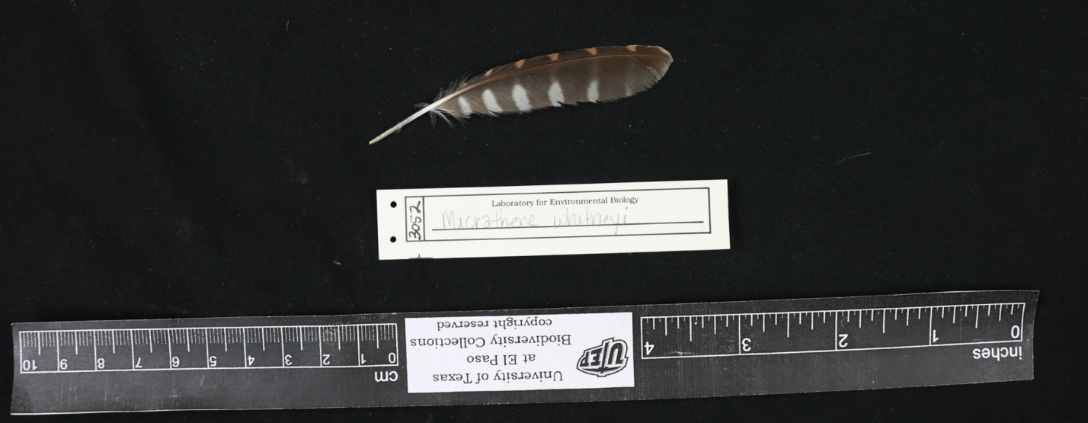
https://arctos.database.museum/MediaSearch.cfm?action=search&media_id=10587861,10587862,10569698

2. 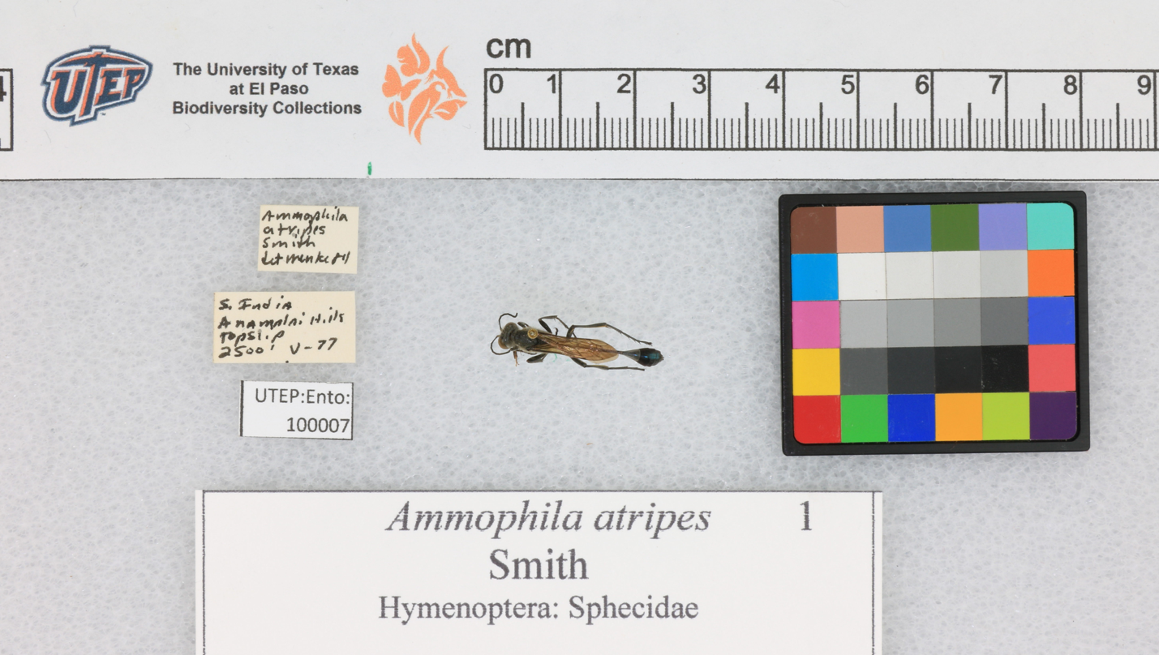
https://web.corral.tacc.utexas.edu/arctos-s3/jegelewicz/2018-07-06/UTEP_ENTO_100007.jpg

3.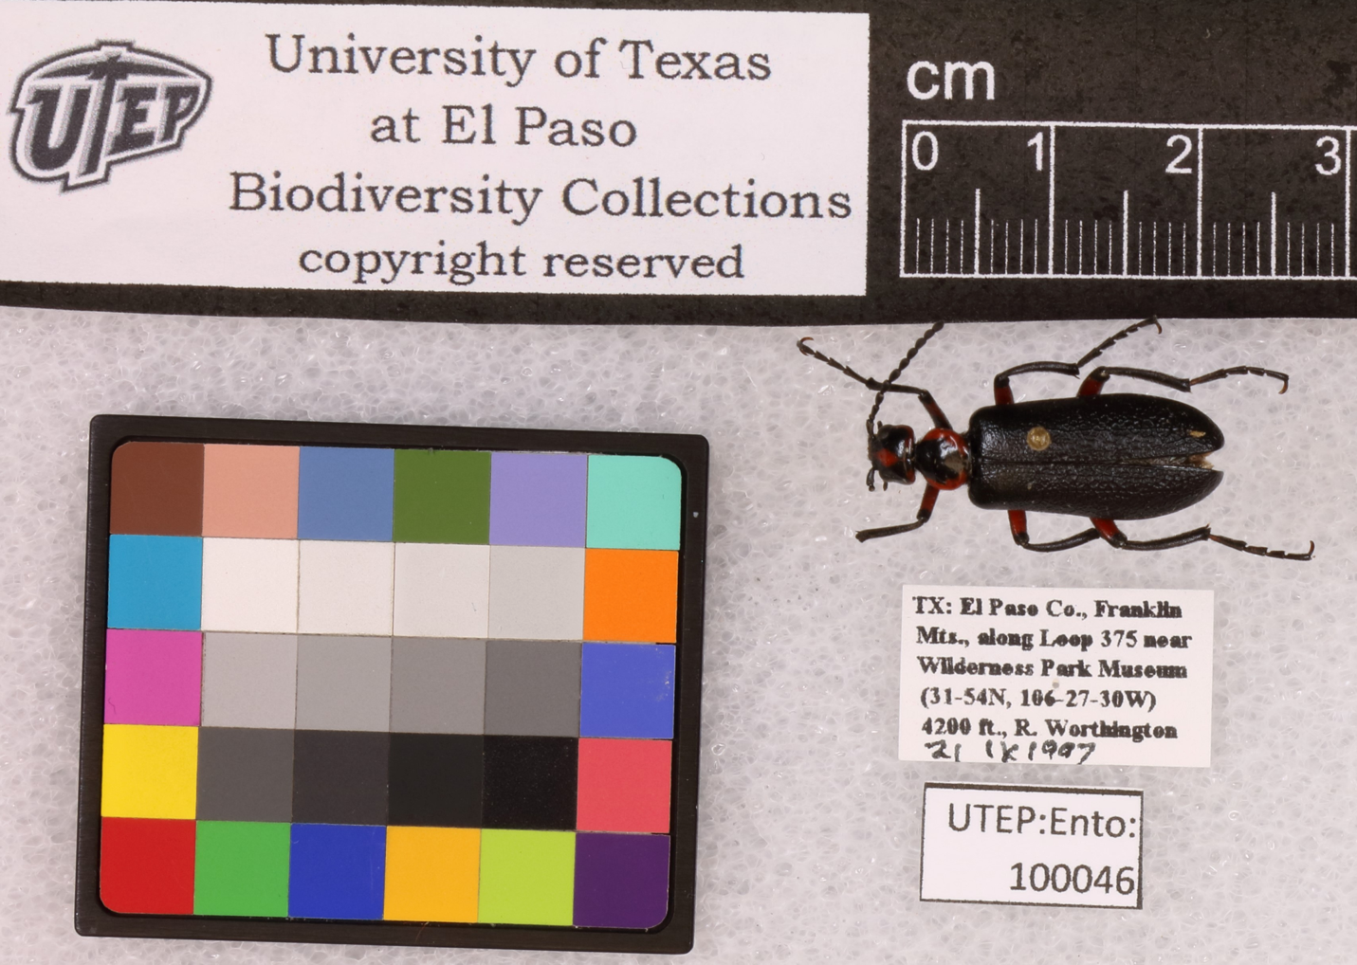
https://web.corral.tacc.utexas.edu/arctos-s3/jegelewicz/2019-08-14/UTEP_Ento_100046.JPG

4. 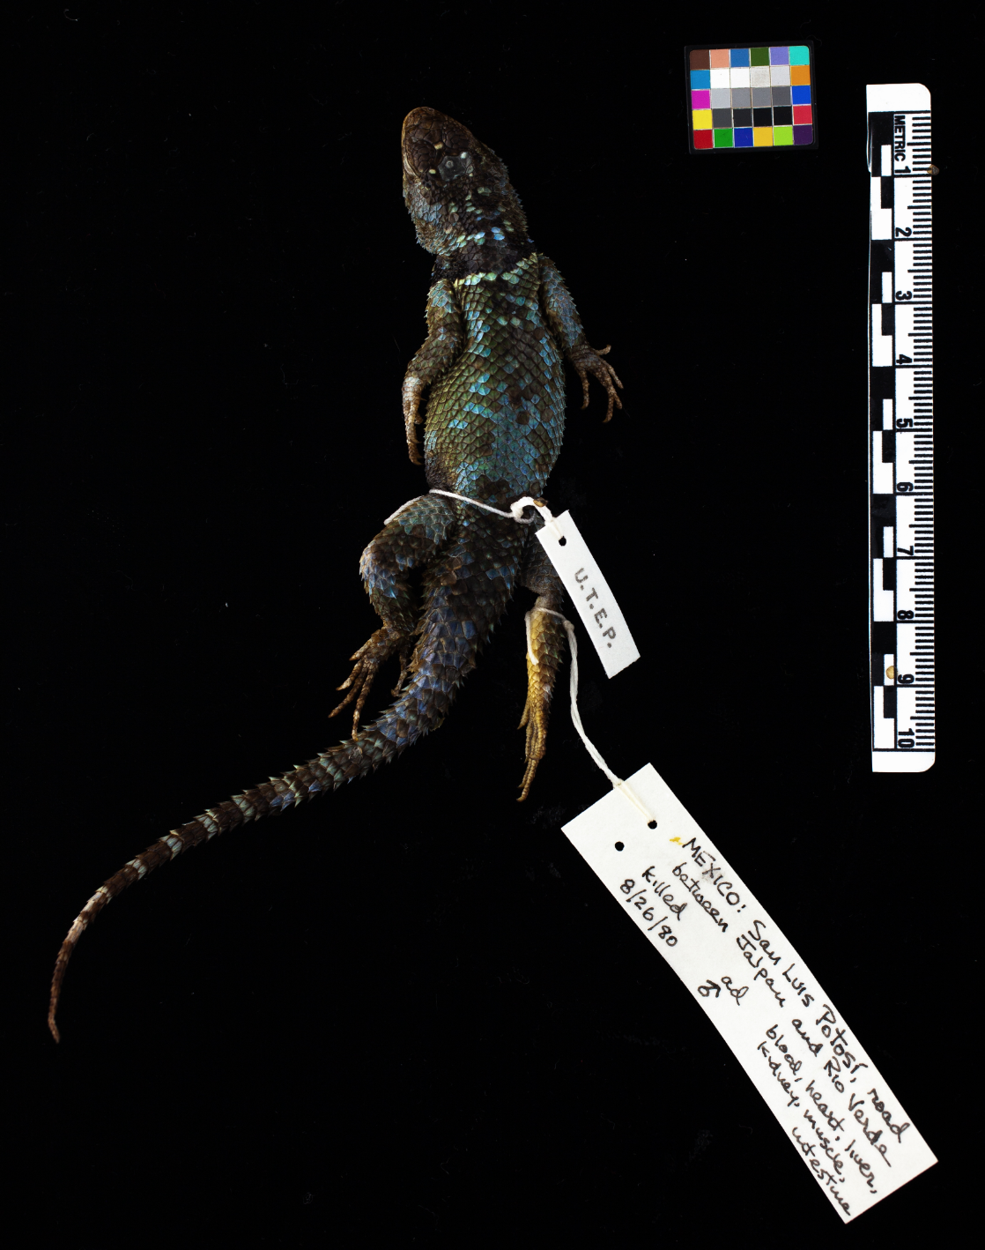
https://arctos.database.museum/MediaSearch.cfm?action=search&media_id=10676963,10676962,10676964,10676965

- 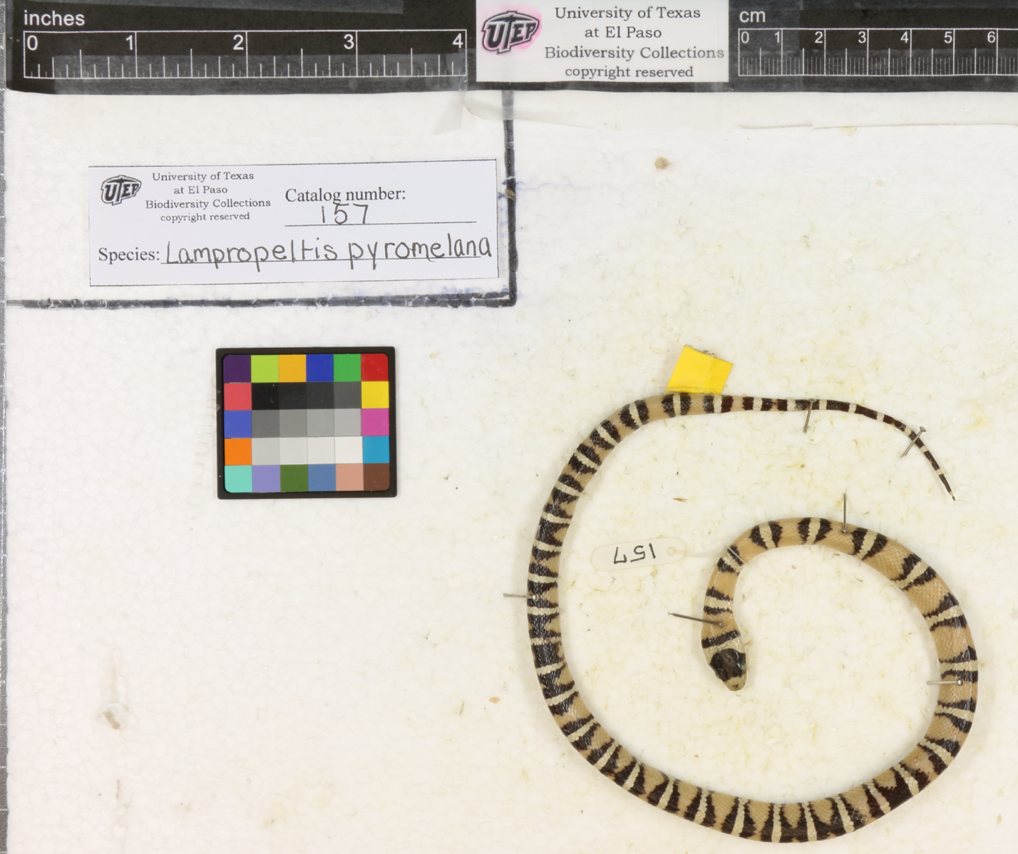
https://arctos.database.museum/MediaSearch.cfm?action=search&media_id=10566251,10566250

Exercise 2:
Look up one of the previous organisms on ARCTOS (https://arctos.database.museum/SpecimenSearch.cfm) . Write 2 sentences about additional information you found (above and beyond the museum specimen tag).

Exercise 3:
You are on a team that has just sampled a mollusk from the Rio Grande. Your professor asks you to create a museum specimen tag. Your professor and you have written down the following information:

This mollusk was sampled from the bank of the Rio Grande River in El Paso, Texas on May 15, 2021 at 2:49pm. It was found near a drain at Rio Grande Bridge, where the river passes under the bridge (coordinates: 31.846295, -106.605848). It was partly cloudy, 88 degrees Fahrenheit, and was recovered on the shore attached to vegetation. The shell was 2mm wide with a faint yellow color and 3 whorls. We have identified the mollusk as a Smooth Coil (Helicodiscus singleyanus).

Additional information [fictional]: We will accession this specimen into the UTEP Biodiversity Collections once it Is properly preserved, and it will receive a museum number UTEP:Inv 1023.

Write a museum tag for your mollusk

Front

Back

Alternate option to exercises: Have students skim the following online resources and summarize major recommendations from each (as appropriate for each class):

- Directions for making a natural history museum specimen tag:
https://spnhc.biowikifarm.net/wiki/Labeling_Natural_History_Collections

- Guidelines for natural history museum specimen labels with glossary of terms:
http://npshistory.com/publications/curation/nh-museum-labels.pdf

- Reading and making arthropod labels (pinned dry specimens and wet specimens) with examples
https://msb.unm.edu/divisions/arthropods/_pdf/specimenlabel.pdf

- Specimen data label examples (and discussion of what ink to use when labeling specimens)
https://core.ac.uk/download/pdf/84926823.pdf

Biological Identification: Describing your findings in the field

Step-by-step (enumerated) directions for students

Biological Identification: Taxa-specific Activity

Step-by-step (enumerated) directions for students

Should be inquiry-based, and allow for some student autonomy, but with enough solid direction so the students don’t feel “lost.”

TAs/instructors should be prepared for student difficulties and frustrations; (guidance can be found in the following “guide for educators”).

May be in multiple parts (brainstorming answers from a discussion question in the pre-lab PowerPoint, writing down the key question they are looking to answer in pairs– followed by class discussion [“think-pair-share”], very directed instruction, hypothesis formulation, asking what understanding has been gained at multiple points, making a tangible final product to either share with the class or submit as an assignment, reflect upon what skills were learned from the module that could be applied to students’ future educational or career goals, refine the key question written at the beginning of class, etc.)

